- DBLocks Node 1
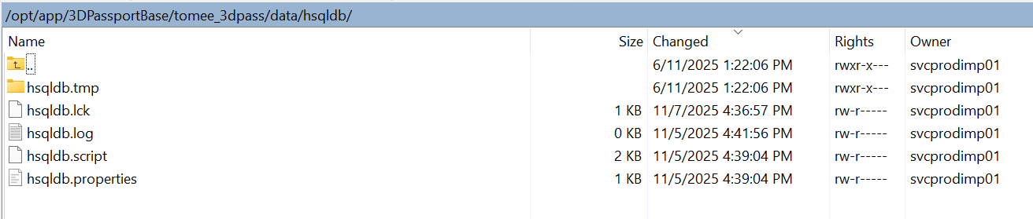
Node 2
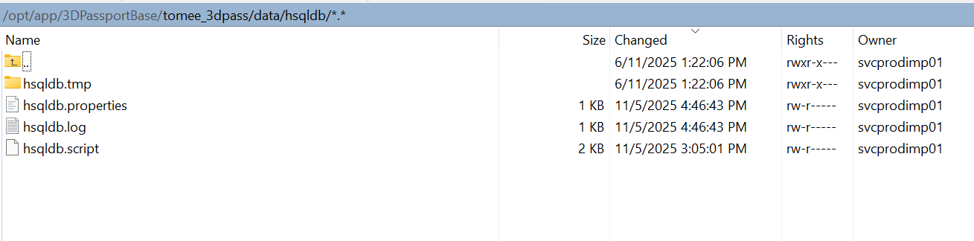

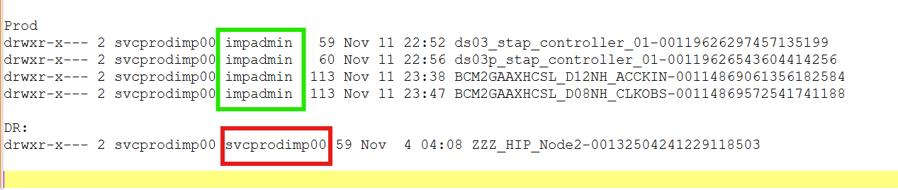

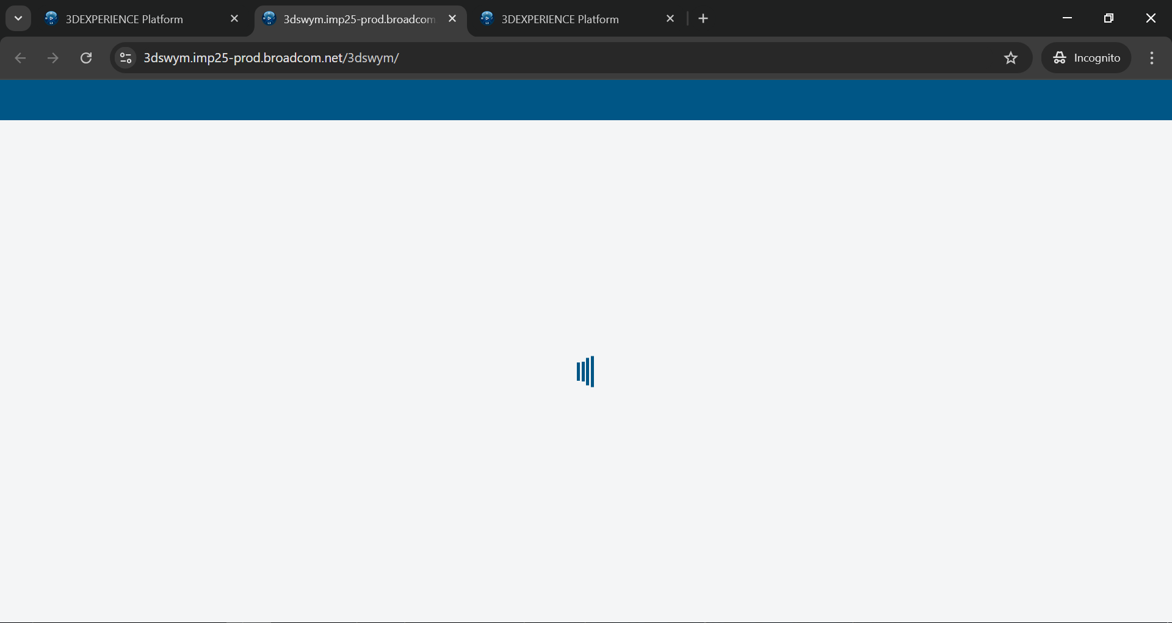

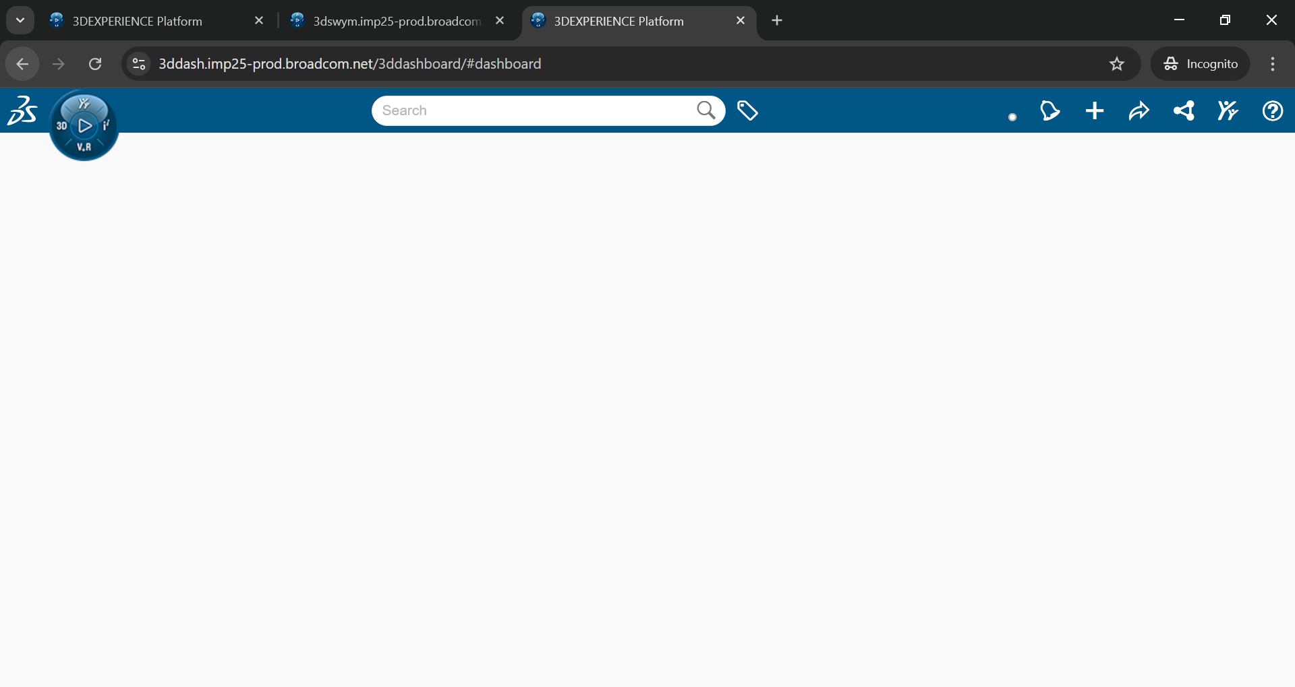

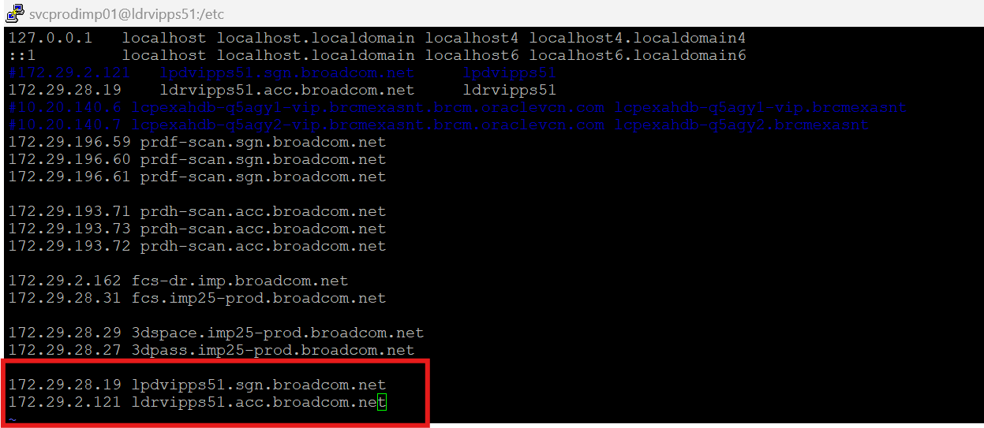

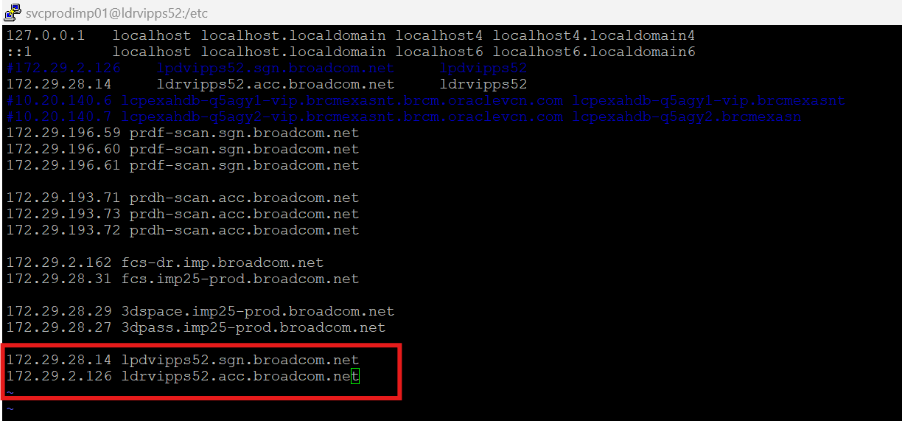

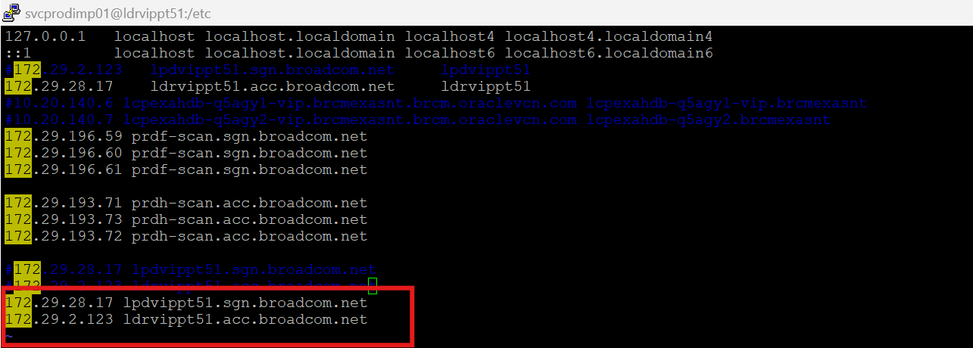

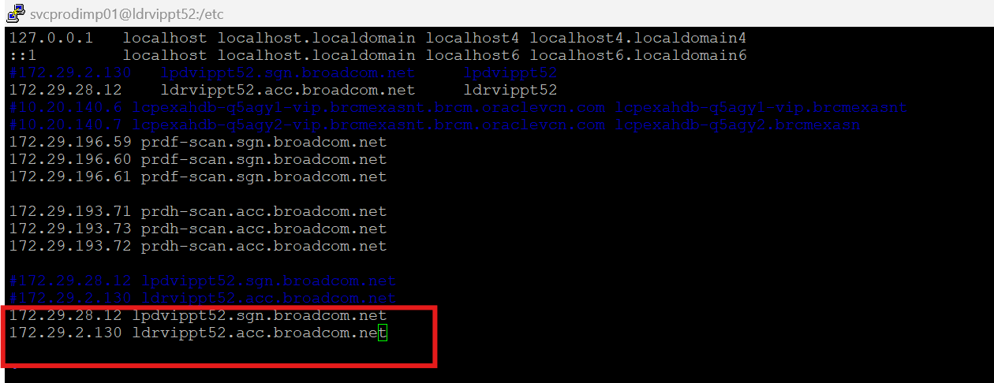

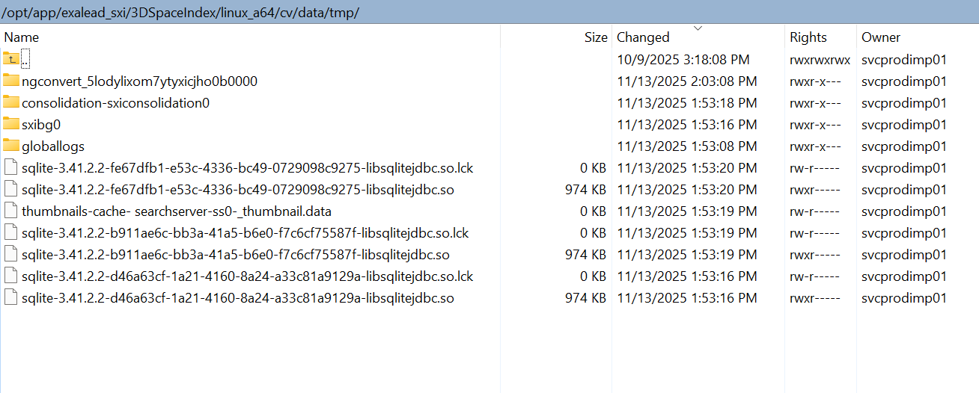
/opt/app/exalead_sxi/3DSpaceIndex/linux_a64/cv/data/tmp
/opt/app/exalead_sxi/3DSpaceIndex/linux_a64/cv/data/run
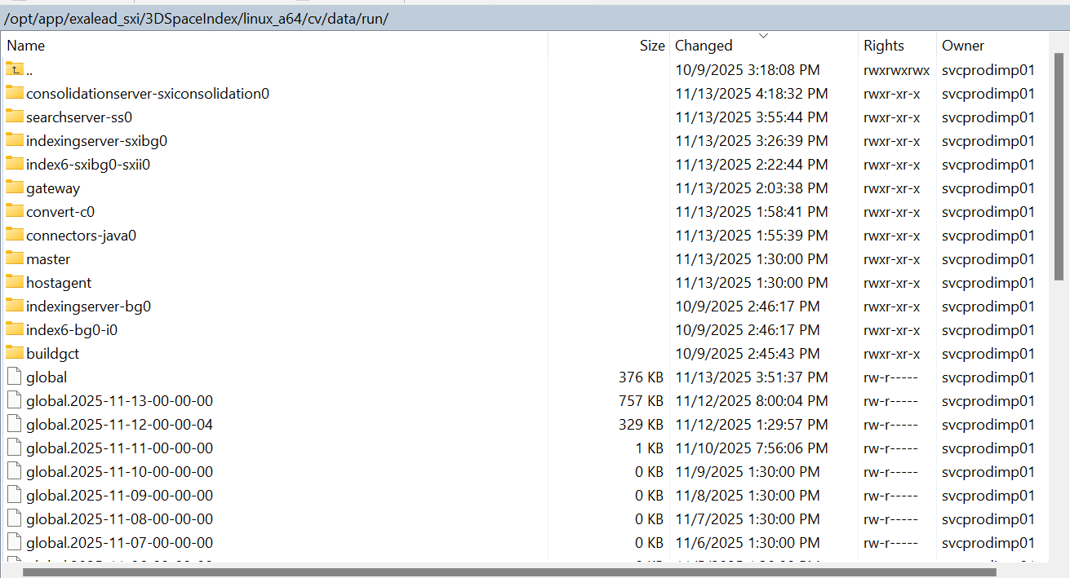

[svcprodimp01@ldrvippt51 ~]$ cd /opt/app/exalead_sxi/3DSpaceIndex/linux_a64/cv/data/reporting_store
[svcprodimp01@ldrvippt51 reporting_store]$ ls -ltrh
total 0
drwxr-xr-x 2 svcprodimp01 svcprodimp01 53 Nov 13 00:00 suggests
drwxr-xr-x 2 svcprodimp01 svcprodimp01 53 Nov 13 00:00 opendocs
drwxr-xr-x 2 svcprodimp01 svcprodimp01 53 Nov 13 00:00 mashup-ui
drwxr-xr-x 2 svcprodimp01 svcprodimp01 53 Nov 13 00:00 mashup-api
[svcprodimp01@ldrvippt51 reporting_store]$
[svcprodimp01@ldrvippt51 reporting_store]$
[svcprodimp01@ldrvippt51 reporting_store]$
[svcprodimp01@ldrvippt51 reporting_store]$ cd ~
[svcprodimp01@ldrvippt51 ~]$
[svcprodimp01@ldrvippt51 ~]$ cd /opt/app/
[svcprodimp01@ldrvippt51 app]$ bash ./shutdown_all.sh
Stopping service...
** Stopping CloudView ...
** CloudView has been successfully stopped.
Waiting for shutdown of following CV processes: 152710 152455 124139 153402 124136 124183 124132 124141
CV stopped in 0 seconds
[svcprodimp01@ldrvippt51 app]$
[svcprodimp01@ldrvippt51 app]$
[svcprodimp01@ldrvippt51 app]$ ps -ef | grep jave
svcprod+ 189975 183617 0 02:48 pts/1 00:00:00 grep --color=auto jave
[svcprodimp01@ldrvippt51 app]$ ps -ef | grep java
svcprod+ 190982 183617 0 02:48 pts/1 00:00:00 grep --color=auto java
[svcprodimp01@ldrvippt51 app]$
[svcprodimp01@ldrvippt51 app]$
[svcprodimp01@ldrvippt51 app]$
[svcprodimp01@ldrvippt51 app]$ ps -ef | grep tomee
svcprod+ 192610 183617 0 02:48 pts/1 00:00:00 grep --color=auto tomee
[svcprodimp01@ldrvippt51 app]$
[svcprodimp01@ldrvippt51 app]$
[svcprodimp01@ldrvippt51 app]$
[svcprodimp01@ldrvippt51 app]$ rm -rf /opt/app/exalead_sxi/3DSpaceIndex/linux_a64/cv/data/tmp/*
[svcprodimp01@ldrvippt51 app]$ rm -rf /opt/app/exalead_sxi/3DSpaceIndex/linux_a64/cv/data/run/*
[svcprodimp01@ldrvippt51 app]$
PROD EXALEAD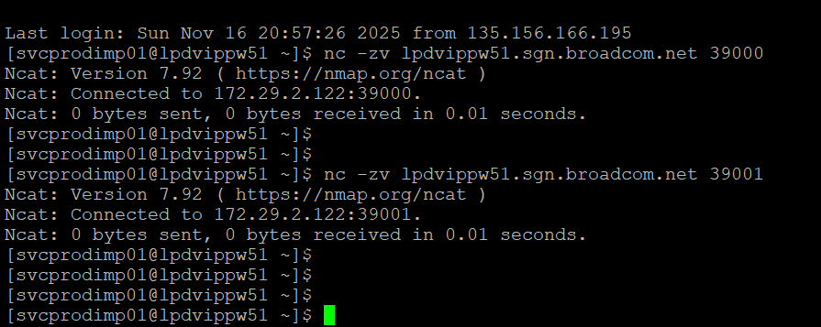

DR EXALEAD
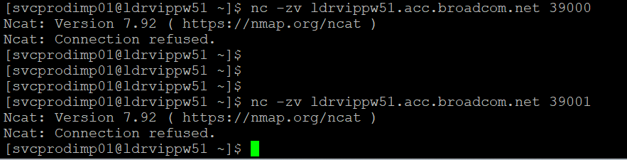

PROD FTS
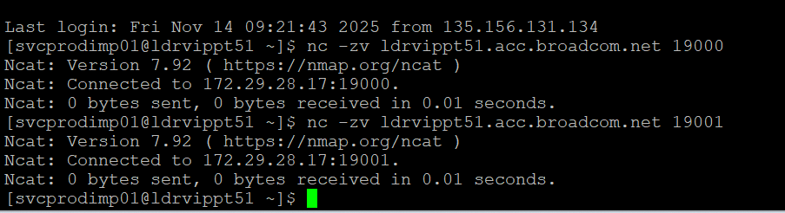

DR FTS
